**PEAS BRIDGE HIGH SCHOOL, MITOOMA**

**END OF TERM ONE**

**SENIOR ONE**

**PHYSICS: THEORY**

Time allowed: 2hours 15 minutes

Name: ……………………………………………STREAM…………………………

Signature: …………………………………………..

**Materials:**

For this paper you must have

* A ruler
* A scientific calculator

**Instructions**

* Answer all questions section A in the spaces provided and ***ONLY*** two questions from section B
* In all calculations, show clearly how you work out your answer

***FOR EXAMINERS USE ONLY***

|  |  |
| --- | --- |
| **SECTION A** |  |
| **SECTION B** |  |
| **TOTAL MARKS** |  |

**SECTION A**

1.  ( 4 marks)

………………………………………………………………………………………………………

……………………………………………………………………………………………………

………………………………………………………………………………………………………

………………………………………………………………………………………………………

………………………………………………………………………………………………………

1. .
2. What is meant by the term laboratory ( 1 mark)

………………………………………………………………………………………………………

……………………………………………………………………………………………………… …………………………………………………………………………………………

1. Write down any 2 laboratory apparatus you know in your school physics laboratory

( 1 mark)

………………………………………………………………………..

……………………………………………………………………….

………………………………………………………………………….

1. State two reasons why you should follow the laboratory rules and regulations ( 2marks)

………………………………………………………………………………………………

………………………………………………………………………………………………………

………………………………………………………………………………………………………

**3.**

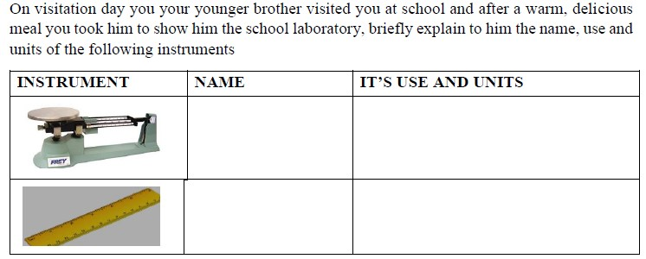

(4 marks)

4.

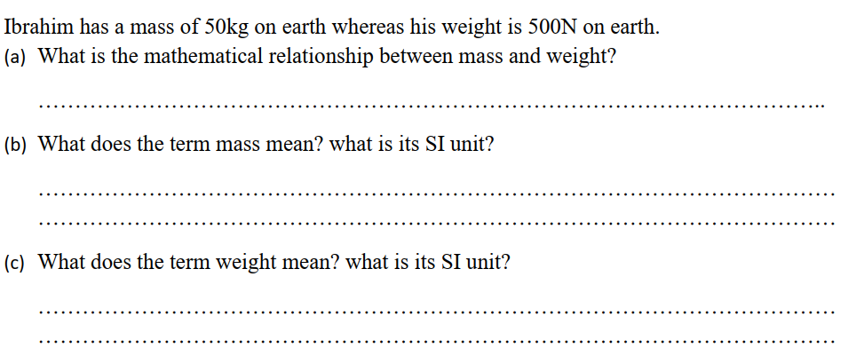

**5.**

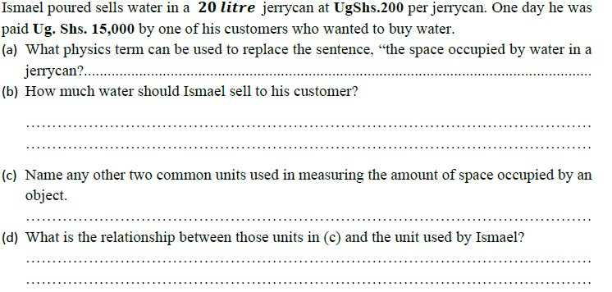

(4 marks)

**6.** State the three fundamental qualities of measurement in physics.(3marks)  
.....................................................................................................................................  
.....................................................................................................................................

**…**………………………………………………………………………………  
b). Match the correct order.  
Quantity. S.I Unit

|  |  |
| --- | --- |
| Temperature. | Seconds |
| Time. | Pascal |
| Pressure. | Kelvin |

7. 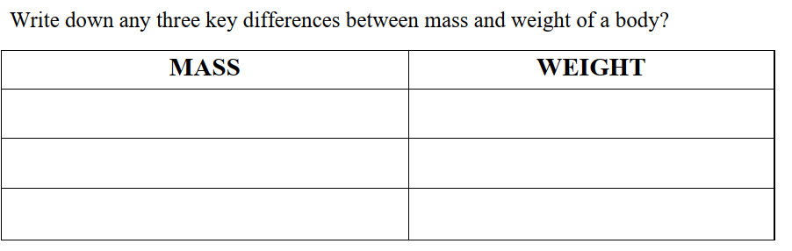(3marks)

8.

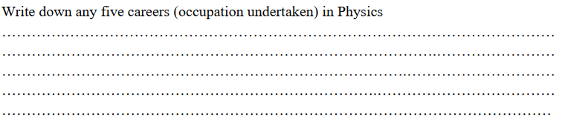 (5marks)

9

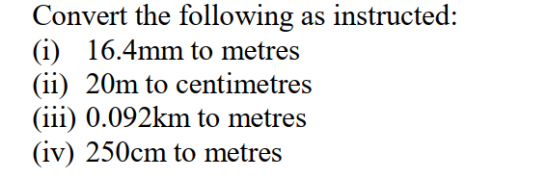 (4marks)

………………………………………………………………………………………………………………………………………………………………………………………………………………………………………………………………………………………………………………………………………………………………………………………………………………………………………………………………………………………………………………………….

10.

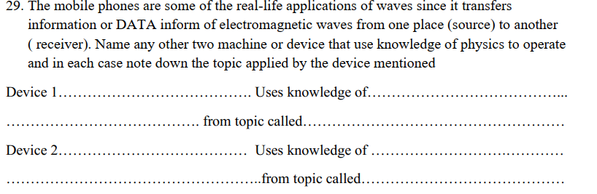(4 marks)

**SECTION B(40 MARKS)**

**Choose two questions from this section.**

11.

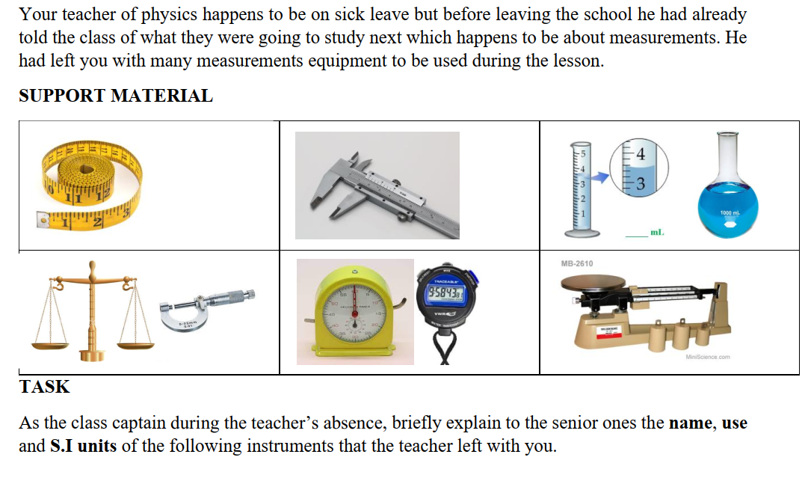

**12.**

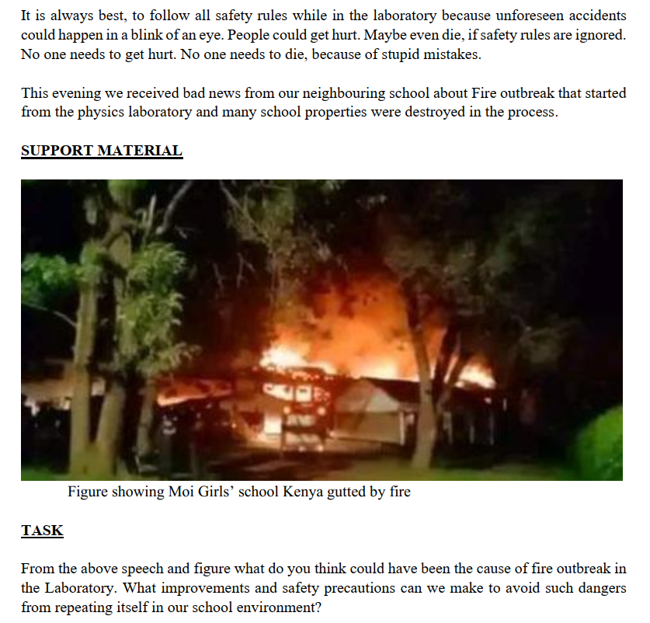

**13.**

**.** 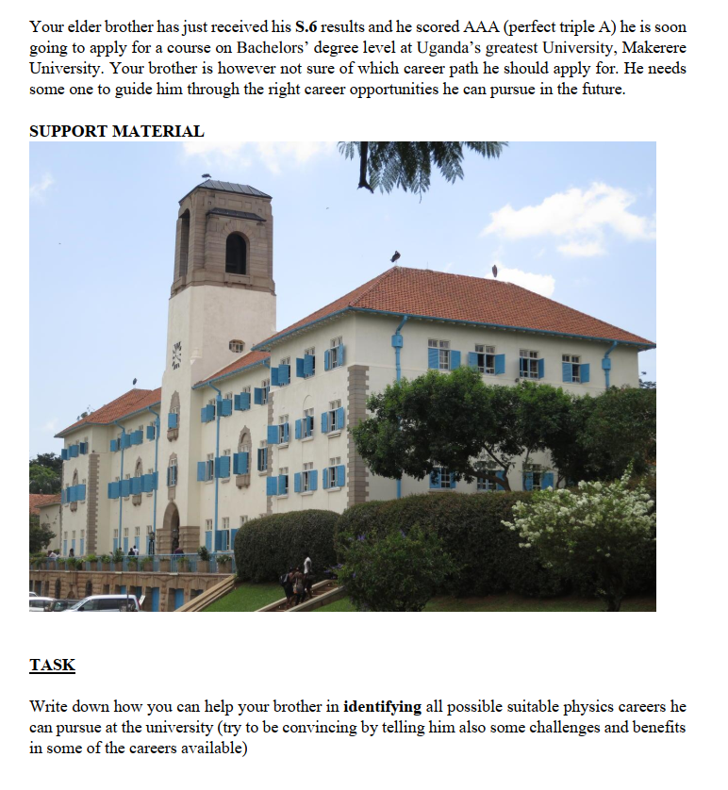

**14.** 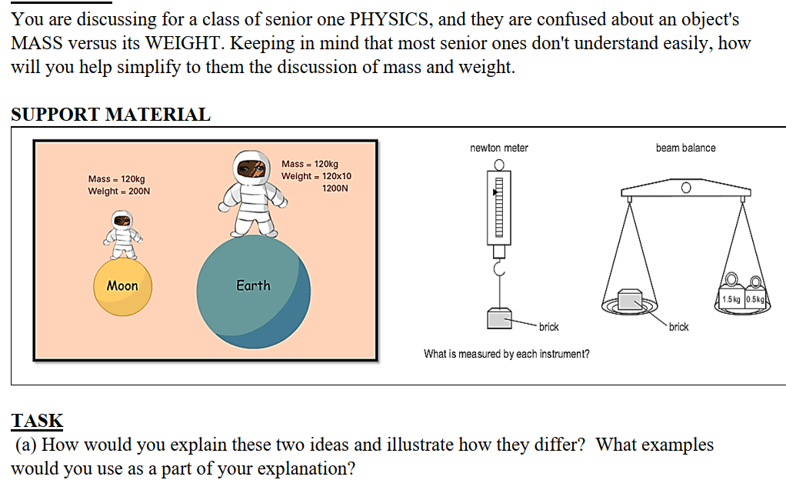

**PHYSICS, THE TRUE SOURCE OF ART AND SCIENCE**

**END**